**Assignment -3**

Digital Marketing

|  |  |
| --- | --- |
| Student Name | Angeline Daphne |
| Student Roll Number | 20URCS005 |
| NM ID | C359CF15BB6916A915C4DABC209622CE |
| College Name | AAA College of Engineering and Technology |

**QUESTION:**

**Create and design a social media advertisement poster using canva.**

**SOCIAL MEDIA ADVERTISEMENT POSTER USING CANVA:**

**Poster link:** https://www.canva.com/design/DAFsh42ue2A/Q9g8PgxBbdVepznYiHsoxw/edit?utm_content=DAFsh42ue2A&utm_campaign=designshare&utm_medium=link2&utm_source=sharebutton

**Poster Title: KinKin Cats**

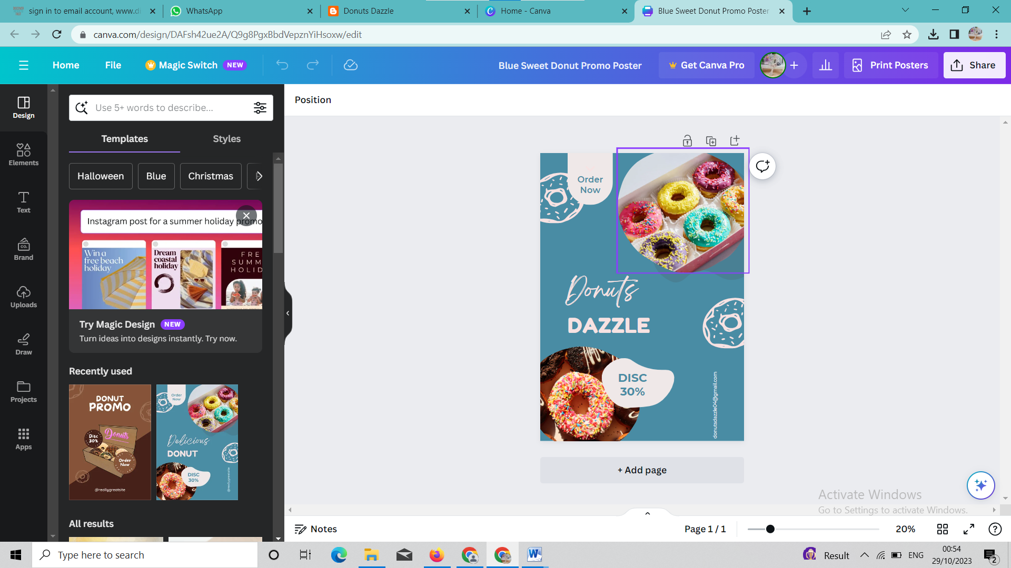

**Poster Image:**

